QMS OVERVIEW
Enterprise Quality Management System Governance and Performance Dashboard
1. PURPOSE OF USE
This document provides an executive overview of the enterprise Quality Management System (QMS). It consolidates governance, process performance, customer and supplier quality, audits, nonconformities, CAPA, document control, competence, risk, change management and management-review actions. The template is intended for the Quality Director, process owners, functional leaders, auditors and executive management.
Executive Management Objectives
Objective | Management Question | Primary Evidence
System Effectiveness | Is the QMS achieving intended results and supporting business objectives? | KPI trends, audit results, customer feedback and process outcomes
Risk and Compliance | Are significant quality, regulatory and operational risks controlled? | Risk register, compliance review and escalation records
Accountability | Are process owners closing gaps, CAPA and management actions on time? | Action register, ownership and effectiveness verification
Resource Adequacy | Are competence, technology, infrastructure and supplier resources sufficient? | Training, capacity, investment and supplier plans
Continual Improvement | Are data and lessons learned converted into measurable improvements? | Improvement portfolio, benefit tracking and management decisions
QMS Governance Model
Governance Level | Primary Responsibilities | Review Cadence | Typical Outputs
Executive Management | Policy, strategic objectives, risk appetite, resources and major priorities | Quarterly / Semiannual | Management-review decisions, funding and escalation direction
QMS Steering Committee | Cross-functional review of KPI, audit, CAPA, compliance and change | Monthly | Integrated action plan and enterprise quality priorities
Process Owners | Process control, local KPI, risk, competence and corrective action | Monthly | Process scorecard and action updates
Quality Function | System assurance, audit, data governance, CAPA oversight and reporting | Ongoing / Monthly | QMS dashboard, audit program and improvement analysis

2. EXECUTIVE QMS DASHBOARD
Reporting Period | May 2025 | Dashboard Owner | Director of Quality | Management Review | Jun 10, 2025
Scope | Enterprise QMS | Comparison | April 2025 | Data Status | Management Review Draft

QMS COMPLIANCE  98.6%  Up 1.8% vs prior month | CAPA CLOSURE  92.4%  Up 3.6% vs prior month | AUDIT COMPLETION  87.5%  Two audits rescheduled | TRAINING COMPLETION  94.7%  Supply Chain remains below target

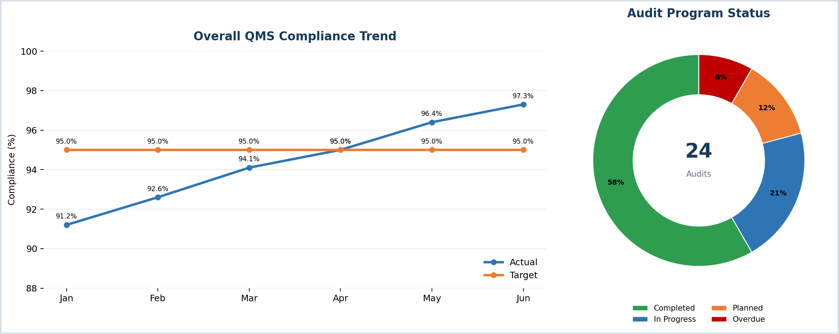

2A. CORRECTIVE ACTION & COMPETENCE ANALYTICS
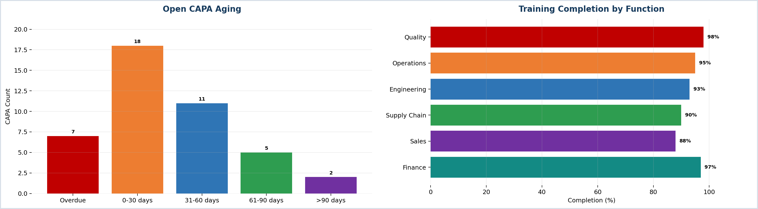
Management Observation | Current Position | Required Direction
CAPA Aging | Seven overdue items and eighteen due within 30 days | Prioritize aging reduction and effectiveness verification
Training | Overall completion 94.7%; Supply Chain is below target | Complete mandatory training and protect learning time

3. QMS ARCHITECTURE & PROCESS GOVERNANCE
The architecture below integrates leadership, planning, operational control, assurance and improvement using the Plan-Do-Check-Act model.
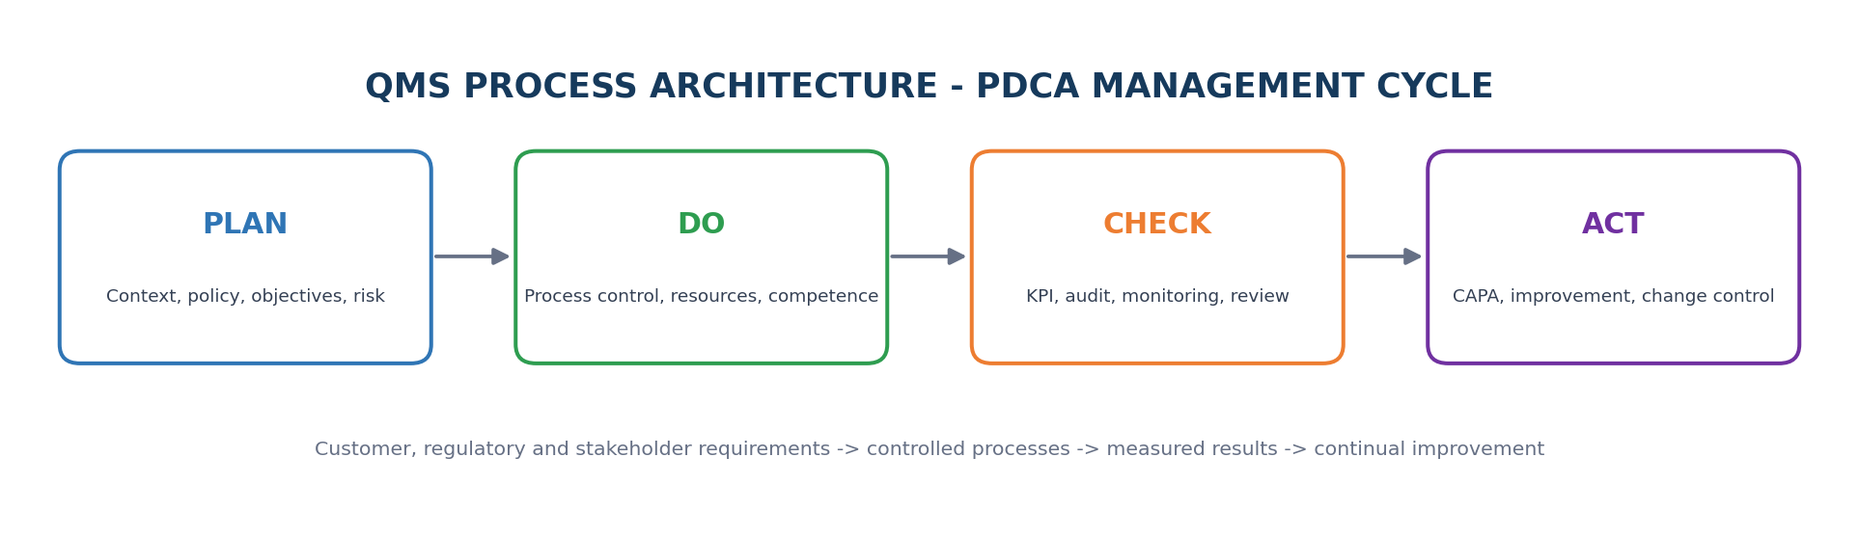
QMS Layer | Core Processes | Director-Level Control | Evidence
Leadership & Direction | Policy, objectives, governance and management review | Strategic alignment and accountability | Approved policy, objectives and review minutes
Planning & Risk | Context, interested parties, risk and change planning | Risk-based thinking and resource prioritization | Risk register, change plans and compliance obligations
Operational Control | Customer, design, purchasing, production/service and release | Process capability and conformance | Procedures, records, specifications and release evidence
Performance Evaluation | KPI, customer feedback, audit and compliance monitoring | Objective performance evaluation | Dashboards, audit reports and trend analysis
Improvement | Nonconformity, CAPA, lessons learned and innovation | Sustained corrective action and benefits realization | CAPA records, effectiveness reviews and improvement plans

4. CORE QMS FUNCTIONS & CONTROLLED FILES
Function | Core Controlled File | Owner | Revision | Status | Next Review | Priority | Executive Attention
Quality Governance | QMS Manual and Process Map | Quality Director | R12 | Approved | Sep 15, 2025 | High | Align with new operating model
Document Control | SOP Master List | Document Control Lead | R18 | Current | Jun 30, 2025 | High | Close 8 overdue reviews
Internal Audit | Risk-Based Audit Program | Lead Auditor | R07 | Current | Jul 01, 2025 | Medium | Two audit dates rescheduled
CAPA | CAPA Register | CAPA Manager | R10 | Under Review | Jun 20, 2025 | High | Effectiveness backlog
Risk Management | Enterprise Quality Risk Register | Risk Manager | R06 | Current | Jul 15, 2025 | High | Supplier continuity and labeling risks
Training & Competence | Training and Competency Matrix | L&D Manager | R09 | Approved | Jun 25, 2025 | Medium | Supply Chain completion gap
Supplier Quality | Approved Supplier List and Scorecard | Supplier Quality Lead | R14 | Current | Jul 31, 2025 | High | Two suppliers under escalation
Change Control | Change Control Register | Quality Systems Manager | R08 | Overdue | May 31, 2025 | High | Regulatory labeling change overdue
Controlled File Review Criteria
Control Area | Minimum Requirement | Escalation Trigger
Approval and Revision | Current approved version, clear owner, revision history and authorization | Unapproved or obsolete document used operationally
Availability | Applicable documents available at point of use and protected from unintended change | Missing or uncontrolled operational instruction
Periodic Review | Review date defined based on risk and process change | Review overdue by more than 30 days
Change Impact | Training, validation, risk and customer/regulatory impact evaluated | High-risk change implemented before approval
Retention and Disposal | Records retained, retrievable and disposed according to approved rules | Missing mandatory evidence or retention breach

5. PROCESS PERFORMANCE SCORECARD
Process | Primary KPI | Target | Actual | Trend | RAG | Owner | Management Action
Customer Quality | Complaint closure within target | >= 95% | 93% | Improving | Amber | Customer Quality Lead | Reduce aged complaint backlog
Manufacturing Quality | First-pass yield | >= 98% | 97.4% | Improving | Amber | Operations Director | Prioritize top loss categories
Supplier Quality | Accepted incoming lots | >= 98% | 96.8% | Declining | Red | Supply Chain Director | Escalate two strategic suppliers
CAPA | CAPA closure on time | >= 95% | 92.4% | Improving | Amber | CAPA Manager | Close effectiveness reviews
Internal Audit | Audit plan completed | >= 95% | 87.5% | Stable | Red | Lead Auditor | Recover delayed audits
Document Control | Documents reviewed on time | >= 98% | 96.5% | Stable | Amber | Document Control Lead | Reassign overdue reviews
Training | Mandatory training completion | >= 95% | 94.7% | Improving | Amber | L&D Manager | Focus on Supply Chain

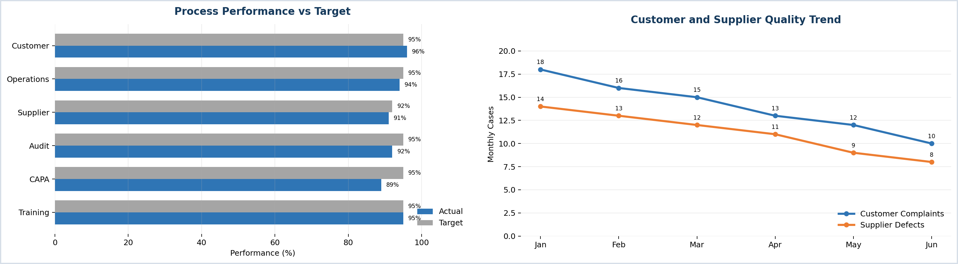

6. AUDIT, NONCONFORMITY & CAPA CONTROL
Record ID | Source | Issue / Finding | Owner | Priority | Due Date | Status | Effectiveness
CAPA-1256 | Internal Audit | Effectiveness verification overdue | CAPA Manager | High | Jun 02, 2025 | Overdue | Pending
AUD-2025-017 | Supplier Audit | Special-process control inconsistency | Supplier Quality Lead | High | Jun 12, 2025 | In Progress | Planned
NC-2025-084 | Operations | Repeated labeling error | Operations Manager | High | Jun 15, 2025 | In Progress | Pending
CAPA-1262 | Customer Complaint | Packaging damage recurrence | Customer Quality Lead | Medium | Jun 20, 2025 | Open | Not Started
AUD-2025-019 | Internal Audit | Training evidence incomplete | L&D Manager | Medium | Jun 25, 2025 | Open | Not Started
NC-2025-091 | Document Control | Obsolete work instruction at point of use | Document Control Lead | High | Jun 08, 2025 | Closed | Effective

6A. ROOT CAUSE & CAPA ANALYTICS
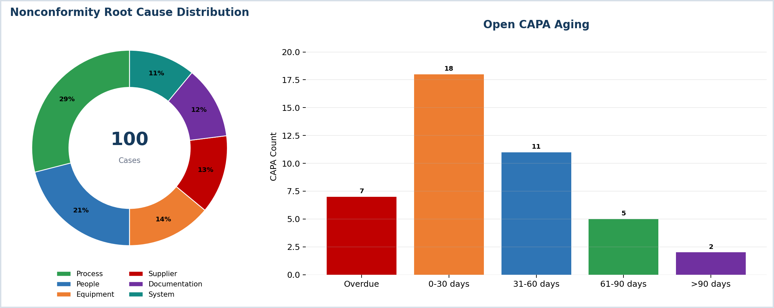
CAPA Effectiveness Verification
Verification Method | Suitable Application | Evidence | Typical Timing
Performance Trend | Recurring process, defect, complaint or yield issue | Sustained KPI improvement and no recurrence | 30-90 days
Audit / Observation | Procedure, behavior, document or control implementation | Audit sample or supervisor observation | 30-60 days
Validation / Test | Technical, software, equipment or product correction | Approved validation or test result | At implementation / defined interval
Customer / Supplier Confirmation | External complaint or supplier action | Customer feedback or supplier performance result | Next delivery / review cycle

7. RISK, COMPETENCE, SUPPLIER & CHANGE CONTROL
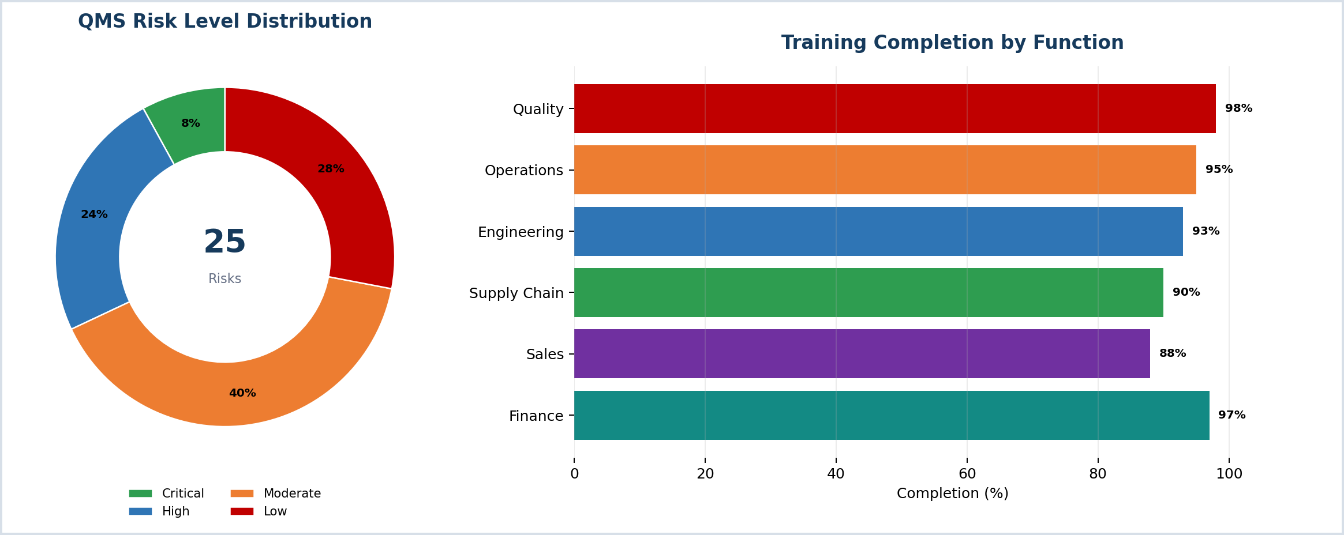

7A. RISK & CONTROL REGISTER
Control Domain | Current Exposure | Owner | Status | Key Control / Action
Regulatory and Compliance | Labeling regulation change | Compliance Director | High | Approve change package and impacted training
Supplier Quality | Two strategic suppliers below target | Supply Chain Director | High | Supplier CAPA, audit and contingency sourcing
Information Security | Controlled QMS data and access risks | CISO | Moderate | Access review, backup and incident exercise
Competence | RCA and audit capability gaps | HR / Quality | Moderate | Targeted training and observed qualification
Change Management | Delayed change impact assessment | Quality Systems Manager | High | Escalate aged change controls and validate implementation
Business Continuity | Quality release and supplier continuity dependency | Operations Director | Moderate | Recovery test and alternate supplier readiness
Change Impact Assessment Checklist
Impact Area | Required Evaluation
Quality and Customer | Product/service conformity, specification, customer approval and complaint risk
Regulatory and Compliance | Legal, regulatory, license, notification and validation impact
Process and Documentation | Procedure, instruction, record, system and workflow updates
People and Competence | Training, qualification, communication and role responsibility
Supplier and Technology | Supplier approval, software, equipment, cybersecurity and continuity
Effectiveness | Success criteria, post-implementation verification and residual risk acceptance

8. MANAGEMENT DECISIONS, ACTIONS & APPROVAL
Action ID | Management Action | Owner | Priority | Due Date | Status | Progress | Required Evidence
MA-001 | Close aged CAPA effectiveness-verification backlog | CAPA Manager | High | Jun 15, 2025 | In Progress | 70% | Verification records and closure approval
MA-002 | Recover delayed internal and supplier audits | Lead Auditor | High | Jun 30, 2025 | Open | 35% | Revised audit plan and completed reports
MA-003 | Approve regulatory labeling change package | Compliance Director | High | Jun 12, 2025 | Overdue | 80% | Approved change and training evidence
MA-004 | Improve supplier performance and continuity controls | Supply Chain Director | High | Jul 15, 2025 | In Progress | 45% | Supplier CAPA and contingency plan
MA-005 | Close overdue controlled-document reviews | Document Control Lead | Medium | Jun 25, 2025 | In Progress | 55% | Updated master list and approvals
MA-006 | Increase mandatory training completion to 97% | L&D Manager | Medium | Jun 30, 2025 | Open | 40% | LMS completion report
Executive Management Summary
Top Risks | Overdue Items | Positive Trends | Improvement Focus
Regulatory labeling change; supplier quality variability; audit delays | 1 regulatory change; 2 audits; 8 document reviews | Compliance and CAPA closure improving; complaint aging reduced | CAPA effectiveness, supplier resilience, audit recovery and document discipline
Approval Record
Role | Name | Decision / Confirmation | Date | Signature
Chief Executive Officer | ________________ | QMS performance and priorities reviewed | ____________ | ________________
Director of Quality | ________________ | Dashboard and actions confirmed | ____________ | ________________
Executive Process Owners | ________________ | Ownership and resources accepted | ____________ | ________________
Quality is everyone's responsibility. Management review converts evidence into accountable improvement.

