EMPLOYEE TRAINING PLAN
Workforce Capability, Competency, Compliance and Development Management
1. PURPOSE OF USE

This document is a professional employee training planning and monitoring template. It supports annual training planning, competency-gap analysis, mandatory compliance training, technical and leadership development, scheduling, attendance, assessment, effectiveness verification, budget monitoring, action tracking and management review. It is intended for Human Resources, Learning & Development, Department Managers, Quality, Safety and Compliance functions.

DOCUMENT STRUCTURE

Section | Management Area | Core Inputs | Management Outputs
1 | Purpose of Use | Scope, users and control principles | Consistent implementation guidance
2 | Executive Training Dashboard | Monthly completion, hours, status and assessment data | KPI cards and colorful performance charts
3 | Employee Training Plan Register | Employee, course, competency, dates, owner and status | Detailed training plan and accountability
4 | Competency & Gap Analysis | Current level, required level and development priority | Competency gap, target roles and development actions
5 | Training Calendar & Delivery Control | Course schedule, trainer, delivery mode, capacity and budget | Calendar visibility and resource planning
6 | Attendance, Assessment & Effectiveness | Attendance, test score, feedback and effectiveness review | Completion evidence and learning impact
7 | Actions & Management Review | Overdue items, owners, due dates and management decisions | Escalation and continual-improvement tracking

HOW TO USE THE TEMPLATE

Step | Instruction
1 | Update the yellow input areas with approved employee, course, competency and scheduling data.
2 | Confirm training requirements against role profiles, legal obligations, QMS procedures and development plans.
3 | Assign a course owner, trainer, budget, delivery mode and target completion date.
4 | Record attendance, assessment results and supporting evidence after delivery.
5 | Evaluate effectiveness through supervisor observation, KPI improvement, audit results or practical demonstration.
6 | Review overdue training, competency gaps, budget variances and improvement actions during management meetings.

TRAINING CONTROL PRINCIPLES

Principle | Control Requirement
Need-Based Planning | Training should be linked to job requirements, competency gaps, risk, change or development objectives.
Ownership | Every training requirement should have an employee, manager, course owner and target date.
Evidence | Retain attendance, materials, assessment results, certificates and effectiveness evidence.
Effectiveness | Completion alone is not sufficient; confirm that knowledge or performance has improved.
Review | Reassess requirements following role changes, incidents, audits, technology changes or regulatory updates.

2. EXECUTIVE TRAINING DASHBOARD

Reporting Period | Jan–Jun 2025 | Plan Owner | Learning & Development | Last Updated | Jun 30, 2025
Training Cycle | Annual | Review Frequency | Monthly | Input Guidance | Replace sample data

TRAINING COMPLETION  94%  ▲ 3% vs prior month | EMPLOYEES TRAINED  286  92% of planned population | AVERAGE ASSESSMENT  90  ▲ 4 points post-training | OVERDUE TRAINING  7  Requires management action

MONTHLY COMPLETION TREND | TRAINING STATUS DISTRIBUTION
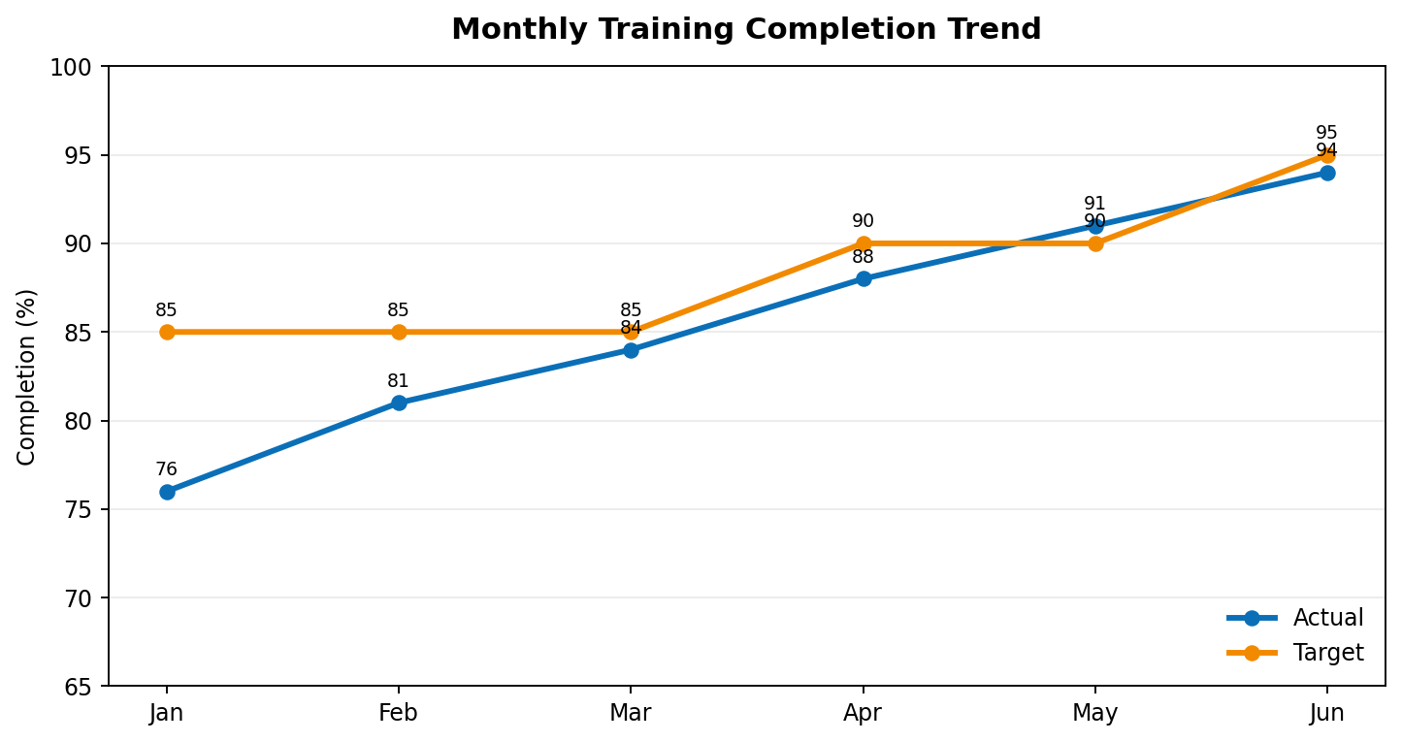 | 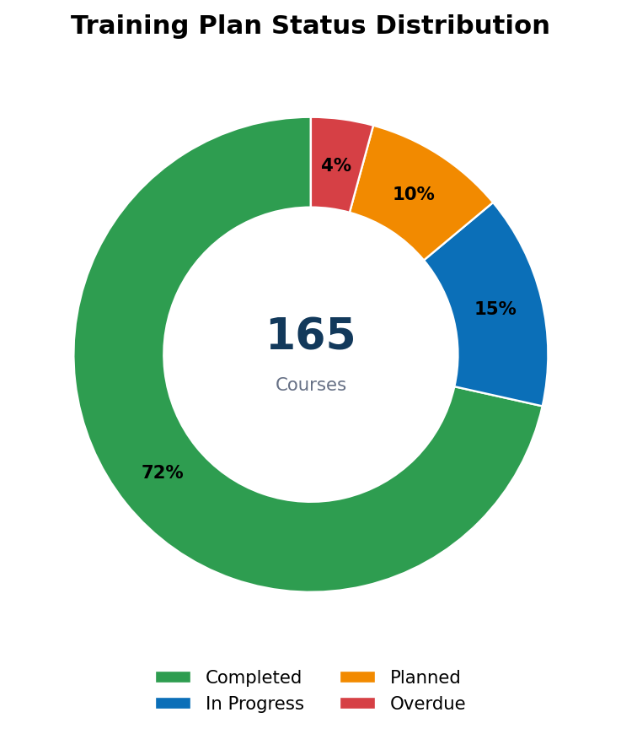

DEPARTMENT COMPLETION | TRAINING HOURS BY PROGRAM TYPE
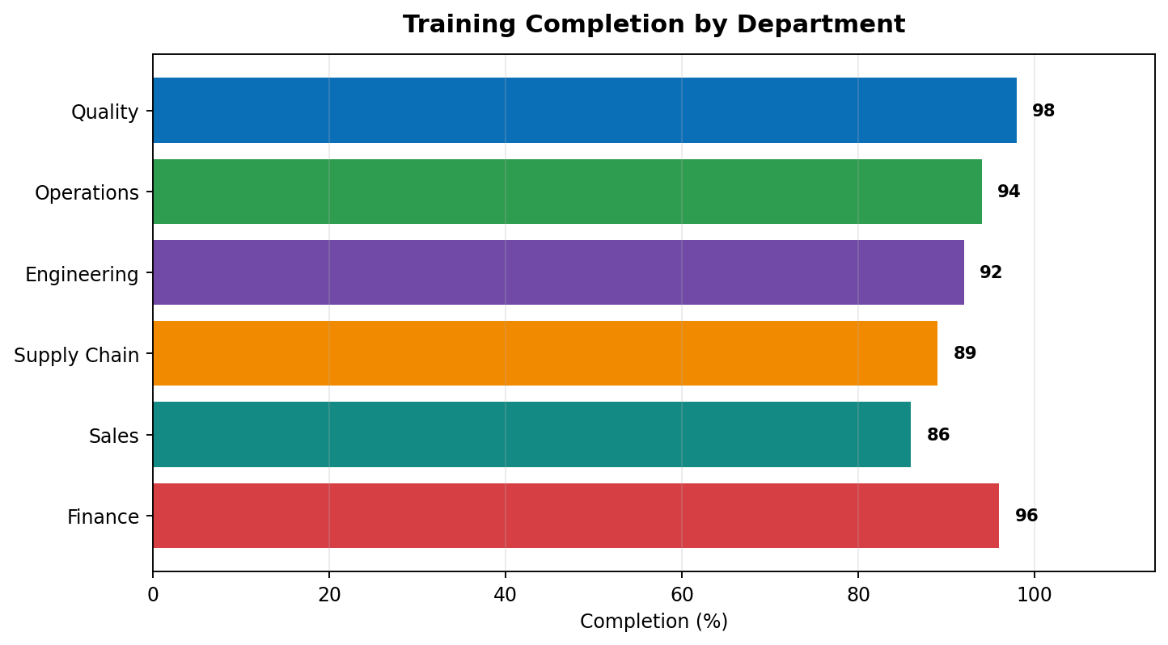 | 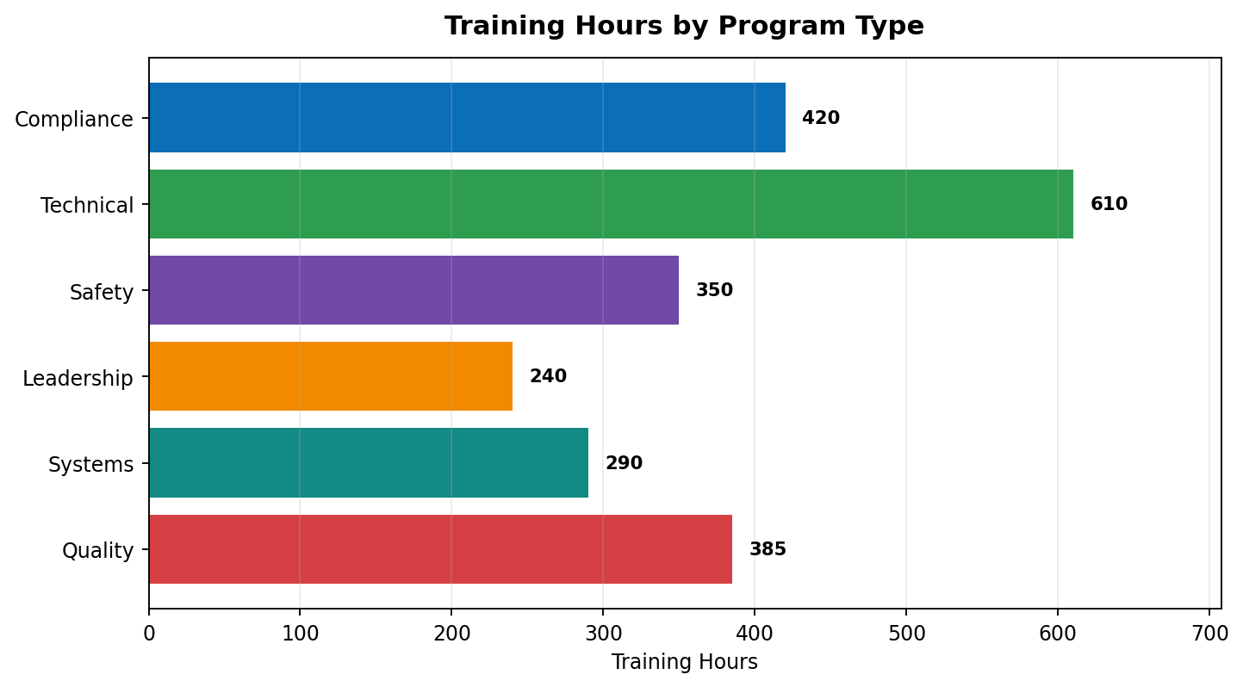

3. EMPLOYEE TRAINING PLAN REGISTER

Plan ID | Employee | Department | Position | Training Program | Training Type | Priority | Planned Date | Status | Course Owner | Estimated Cost | Evidence Required
TRN-001 | Emma Johnson | Quality | Quality Specialist | Internal Auditor Development | Quality | High | Jul 10, 2025 | Scheduled | Quality Manager | $650 | Certificate + audit observation
TRN-002 | Liam Chen | Engineering | Maintenance Engineer | Advanced Equipment Diagnostics | Technical | High | Jul 15, 2025 | Planned | Engineering Manager | $900 | Practical assessment
TRN-003 | Sofia Patel | Operations | Line Supervisor | Root Cause Analysis & CAPA | Quality | High | Jul 18, 2025 | In Progress | Quality Manager | $500 | Case-study assessment
TRN-004 | Noah Williams | Supply Chain | Buyer | Supplier Risk & Qualification | Compliance | Medium | Jul 22, 2025 | Scheduled | Supply Chain Director | $420 | Knowledge test
TRN-005 | Olivia Brown | Sales | Account Manager | Customer Complaint Handling | Customer | Medium | Jul 25, 2025 | Planned | Customer Quality Lead | $350 | Role-play evaluation
TRN-006 | Ethan Davis | Finance | Financial Analyst | Data Privacy & Information Security | Compliance | High | Jul 28, 2025 | Completed | Information Security | $280 | Certificate
TRN-007 | Ava Nguyen | Operations | Production Technician | Machine Safety & LOTO | Safety | High | Aug 05, 2025 | Scheduled | EHS Manager | $300 | Practical demonstration
TRN-008 | Mason Lee | HR | HR Business Partner | Leadership Coaching Skills | Leadership | Medium | Aug 12, 2025 | Planned | HR Director | $720 | Coaching observation
TRN-009 | Isabella Garcia | Quality | Document Controller | Electronic Document Management System | Systems | Medium | Aug 18, 2025 | In Progress | Document Control Lead | $460 | System proficiency test
TRN-010 | Lucas Martin | Engineering | Process Engineer | Statistical Process Control | Technical | High | Aug 22, 2025 | Planned | Engineering Manager | $780 | SPC project

TRAINING REQUIREMENT DEFINITION

Requirement Source | Examples | Planning Control
Role Competency | Job profile, skill matrix, succession plan | Compare current and required proficiency.
Compliance | Legal, regulatory, safety, information security | Set mandatory frequency and completion deadline.
Quality System | ISO procedures, audit findings, CAPA, document changes | Link training to controlled documents and effectiveness evidence.
Performance Improvement | KPI gap, error trend, customer complaint, rework | Define expected performance improvement.
Development | Career plan, leadership pipeline, future-role readiness | Agree target capability and post-training application.

4. COMPETENCY & GAP ANALYSIS

Employee / Role | Competency | Current Level | Required Level | Gap | Risk if Not Addressed | Development Action | Target Date | Owner
Emma Johnson / Quality Specialist | Internal Auditing | Intermediate | Advanced | 1 Level | Audit quality and consistency | Lead two supervised audits | Sep 30, 2025 | Quality Manager
Liam Chen / Maintenance Engineer | Diagnostic Analysis | Intermediate | Advanced | 1 Level | Extended equipment downtime | Complete advanced diagnostics course | Aug 31, 2025 | Engineering Manager
Sofia Patel / Line Supervisor | Root Cause Analysis | Basic | Advanced | 2 Levels | Recurring deviations | RCA workshop plus coached CAPA | Sep 15, 2025 | Operations Manager
Noah Williams / Buyer | Supplier Risk Management | Basic | Intermediate | 1 Level | Supplier quality and continuity exposure | Supplier-risk qualification program | Aug 31, 2025 | Supply Chain Director
Olivia Brown / Account Manager | Complaint Investigation | Basic | Intermediate | 1 Level | Slow or inconsistent customer response | Complaint-handling simulation | Aug 15, 2025 | Customer Quality Lead
Ava Nguyen / Production Technician | Machine Safety | Intermediate | Advanced | 1 Level | Safety incident or non-compliance | LOTO practical certification | Aug 20, 2025 | EHS Manager
Mason Lee / HR Business Partner | Coaching | Intermediate | Advanced | 1 Level | Weak manager capability development | Leadership coaching practicum | Oct 15, 2025 | HR Director

COMPETENCY LEVEL VS REQUIREMENT | ASSESSMENT IMPROVEMENT
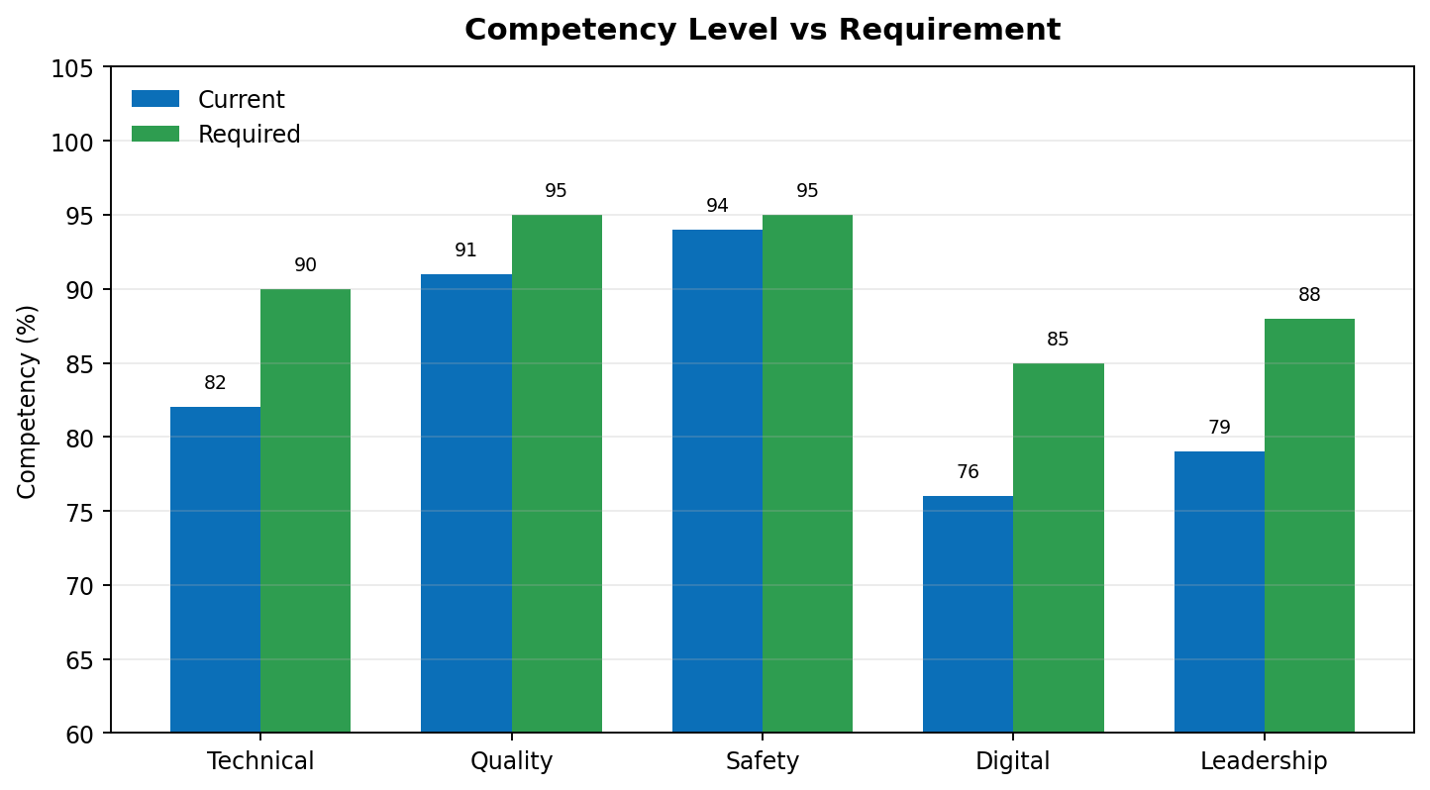 | 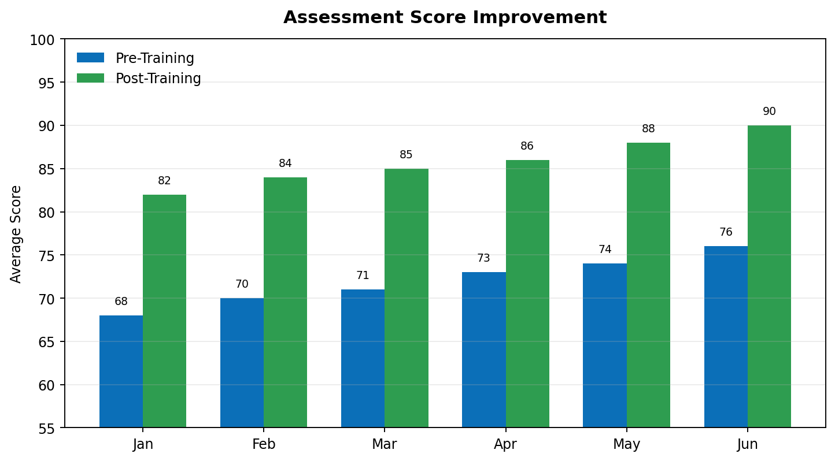

5. TRAINING CALENDAR & DELIVERY CONTROL

Date | Training / Event | Audience | Trainer / Provider | Mode | Capacity | Registered | Budget | Location / Platform | Status
Jul 10, 2025 | Internal Auditor Development | Quality & Process Owners | External Lead Auditor | Classroom | 18 | 16 | $3,200 | Training Room A | Scheduled
Jul 15, 2025 | Advanced Equipment Diagnostics | Engineering & Maintenance | Equipment Vendor | Workshop | 15 | 14 | $4,500 | Engineering Lab | Scheduled
Jul 18, 2025 | Root Cause Analysis & CAPA | Supervisors & Quality | Quality Manager | Workshop | 24 | 22 | $1,200 | Training Room B | In Progress
Jul 22, 2025 | Supplier Risk & Qualification | Supply Chain & Quality | Supplier Quality Lead | Virtual | 30 | 26 | $900 | Teams | Scheduled
Jul 25, 2025 | Customer Complaint Handling | Sales & Customer Service | Customer Quality Lead | Workshop | 20 | 18 | $1,100 | Training Room A | Planned
Jul 28, 2025 | Data Privacy & Information Security | All Office Employees | Information Security | E-learning | 120 | 115 | $1,800 | LMS | Completed
Aug 05, 2025 | Machine Safety & LOTO | Operations & Maintenance | EHS Manager | Practical | 25 | 21 | $1,500 | Production Area | Scheduled
Aug 12, 2025 | Leadership Coaching Skills | Managers & HR | Leadership Consultant | Classroom | 18 | 14 | $4,200 | Executive Room | Planned

DELIVERY READINESS CHECKLIST

Control Item | Owner | Due Date | Status | Evidence / Comment
Training need and audience approved | Department Manager | 10 days before | Complete | Approved training request
Trainer qualification confirmed | Course Owner | 10 days before | Complete | Trainer CV / qualification
Materials and controlled documents approved | Course Owner | 5 days before | In Progress | Final review pending
Venue / platform and equipment confirmed | L&D Coordinator | 3 days before | Complete | Booking confirmation
Attendance and assessment records prepared | L&D Coordinator | 1 day before | Planned | Templates in LMS
Effectiveness method agreed | Manager / Quality | Before delivery | In Progress | Observation and KPI review

6. ATTENDANCE, ASSESSMENT & EFFECTIVENESS

Employee | Program | Attendance | Pre-Test | Post-Test | Feedback | Practical Result | Effectiveness Method | Review Date | Result
Emma Johnson | Internal Auditor Development | 100% | 78 | 92 | 4.7 / 5 | Passed | Supervisor audit observation | Sep 30, 2025 | Pending
Liam Chen | Advanced Equipment Diagnostics | 100% | 72 | 90 | 4.6 / 5 | Passed | Downtime and troubleshooting KPI | Oct 15, 2025 | Pending
Sofia Patel | Root Cause Analysis & CAPA | 100% | 64 | 88 | 4.8 / 5 | Passed | Quality of next two CAPAs | Sep 15, 2025 | Effective
Noah Williams | Supplier Risk & Qualification | 100% | 70 | 86 | 4.4 / 5 | Passed | Supplier qualification review | Sep 30, 2025 | Pending
Olivia Brown | Customer Complaint Handling | 90% | 68 | 84 | 4.5 / 5 | Passed | Complaint response quality | Sep 15, 2025 | Effective
Ethan Davis | Data Privacy & Information Security | 100% | 82 | 96 | 4.6 / 5 | Passed | Phishing simulation result | Aug 31, 2025 | Effective
Ava Nguyen | Machine Safety & LOTO | 100% | 75 | 94 | 4.9 / 5 | Passed | Practical safety observation | Sep 10, 2025 | Pending

EFFECTIVENESS VERIFICATION CRITERIA

Method | Suitable Application | Evidence | Suggested Review Timing
Knowledge Assessment | Policy, compliance, process and technical knowledge | Post-test or certification result | Immediately after training
Practical Demonstration | Equipment, safety, laboratory or operational skills | Observed competency checklist | Immediately or within 30 days
Supervisor Observation | Behavior, leadership, customer service and process execution | Manager observation record | 30–90 days
KPI / Performance Review | Yield, errors, downtime, complaints or productivity | Before-and-after KPI analysis | 30–90 days
Audit / Compliance Review | QMS, safety, regulatory and controlled-process training | Audit results or compliance evidence | Next audit or defined cycle

7. TRAINING ACTIONS & MANAGEMENT REVIEW

Action ID | Issue / Improvement | Owner | Priority | Due Date | Status | % Complete | Required Evidence | Management Decision
TA-001 | Close seven overdue mandatory training assignments | L&D Coordinator | High | Jul 10, 2025 | In Progress | 70% | LMS completion report | Escalate remaining employees to managers
TA-002 | Improve Supply Chain completion from 89% to at least 95% | Supply Chain Director | High | Jul 31, 2025 | Open | 30% | Department completion report | Schedule protected learning time
TA-003 | Complete effectiveness reviews for technical training | Engineering Manager | Medium | Aug 15, 2025 | In Progress | 45% | Observation and KPI evidence | Review at monthly operations meeting
TA-004 | Update role competency profiles for new digital systems | HR Director | Medium | Aug 31, 2025 | Planned | 20% | Approved competency profiles | Align with system go-live
TA-005 | Reduce unplanned training requests through quarterly planning | L&D Manager | Low | Sep 15, 2025 | Planned | 10% | Quarterly training forecast | Add requirement review to business planning

MANAGEMENT REVIEW SUMMARY

TOP RISKS | OVERDUE ITEMS | POSITIVE TRENDS | IMPROVEMENT FOCUS
• Mandatory training overdue  • Competency gaps in RCA and diagnostics  • Supply Chain completion below target | 7 overdue assignments  2 effectiveness reviews pending  1 course over budget | Completion improved to 94%  Post-test scores improved  Quality department reached 98% | • Protect learning time  • Strengthen effectiveness verification  • Link training plans to competency profiles

APPROVAL & FOLLOW-UP

Role | Name | Decision / Confirmation | Date | Signature
Learning & Development Manager | ________________ | Training plan reviewed | ____________ | ________________
Human Resources Director | ________________ | Resources and priorities approved | ____________ | ________________
Department Management | ________________ | Employee release and follow-up accepted | ____________ | ________________
Quality / Compliance | ________________ | Mandatory and QMS requirements confirmed | ____________ | ________________
Management Control Note: Completion records should be retained with attendance, assessment, certificate, practical demonstration and effectiveness-verification evidence.

