CORRECTIVE ACTION PLAN
Enterprise Quality Improvement, Root Cause and Effectiveness Management
1. PURPOSE OF USE
This template provides a director-level framework for controlling corrective actions arising from nonconformities, customer complaints, audit findings, process failures, incidents, supplier issues and management review. It supports immediate containment, structured root-cause investigation, action planning, implementation tracking, effectiveness verification, recurrence prevention, closure approval and executive oversight.
DOCUMENT ORGANIZATION
Section | Management Area | Core Inputs | Management Outputs
1 | Purpose of Use | Scope, governance and use instructions | Consistent corrective-action management
2 | Executive Dashboard | Status, aging, priorities and closure results | KPI cards and management analytics
3 | Corrective Action Register | Issue, source, owner, priority, dates and status | Accountability, aging and escalation
4 | Root Cause Investigation | Problem statement, evidence, method and root cause | Validated causal analysis and risk controls
5 | Action Plan & Implementation | Tasks, owners, due dates, evidence and progress | Implementation tracking and completion control
6 | Effectiveness & Recurrence Control | Verification criteria, review dates and results | Evidence of effectiveness and non-recurrence
7 | Management Review & Approval | Risks, overdue items, resources and decisions | Executive decisions, approval and follow-up

CORRECTIVE ACTION GOVERNANCE PRINCIPLES
Principle | Director-Level Control Requirement
Containment | Protect customers, employees, compliance and operations before long-term correction.
Root Cause | Address verified system causes rather than symptoms or unsupported assumptions.
Ownership | Assign one accountable owner with authority, resources and a committed due date.
Evidence | Retain objective evidence for investigation, implementation and effectiveness verification.
Effectiveness | Close actions only after confirming the issue is controlled and recurrence risk is reduced.
Learning | Share lessons learned and update standards, risk registers, training and controls where required.

ENTERPRISE CORRECTIVE ACTION LIFECYCLE
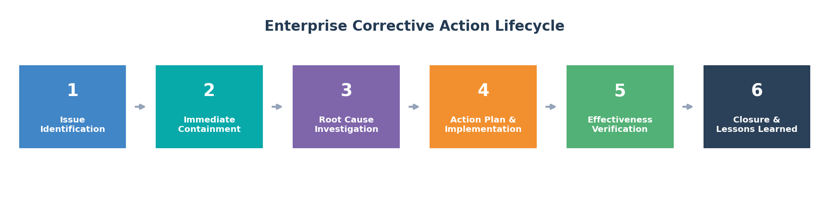
2. EXECUTIVE CORRECTIVE ACTION DASHBOARD
Reporting Period | January-June 2025 | Plan Owner | Quality Systems Director | Review Cycle | Monthly
Total Portfolio | 51 actions | Executive Review | June 30, 2025 | Input Status | Illustrative sample data

OPEN ACTIONS  23  7 overdue | ON-TIME CLOSURE  86%  +5% vs prior quarter | AVERAGE AGING  32 days  Target: <=30 days | HIGH / CRITICAL  11  Requires director focus | EFFECTIVENESS VERIFIED  78%  5 reviews pending | RECURRENCE RATE  4.2%  Down from 7.2%

EXECUTIVE ANALYTICS
MONTHLY ACTION TREND | PORTFOLIO STATUS
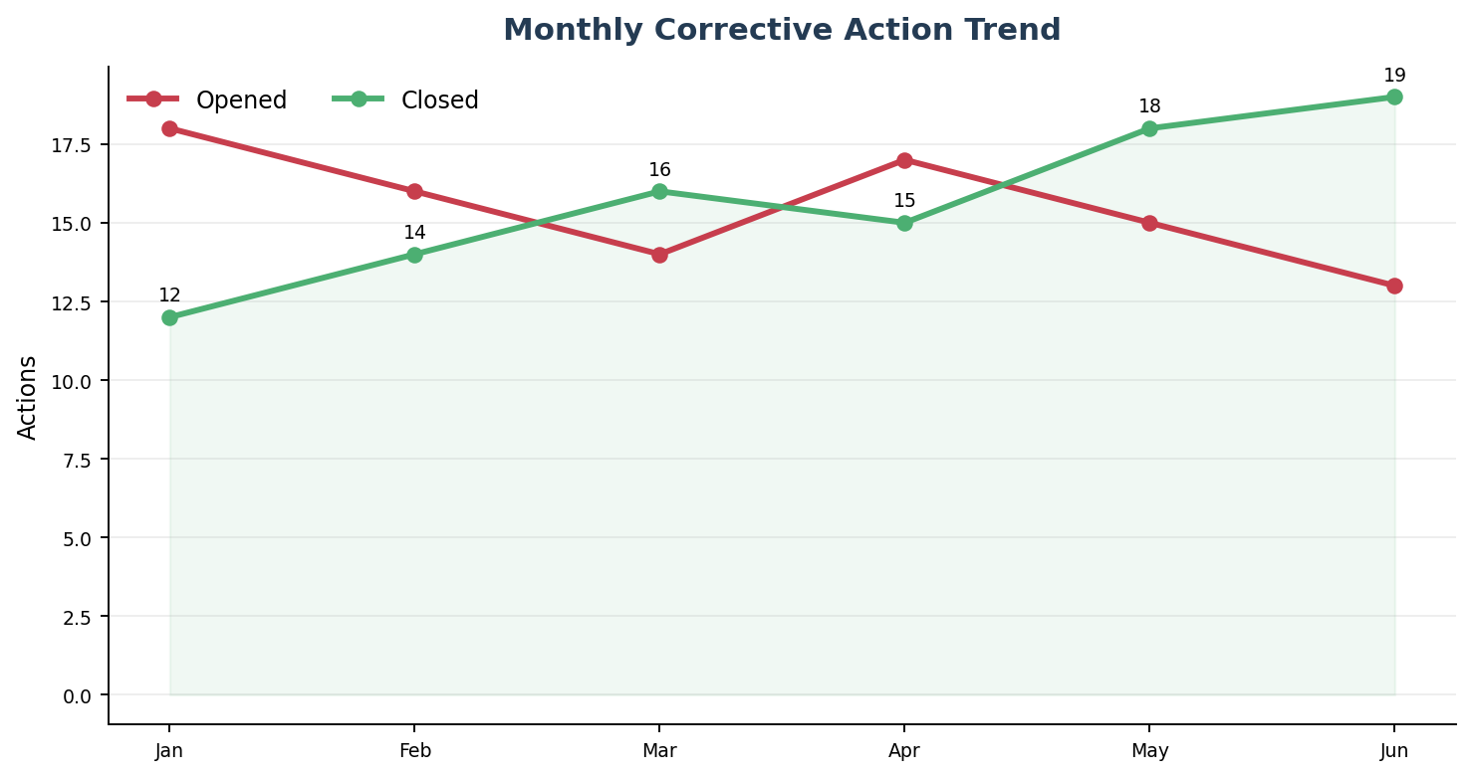 | 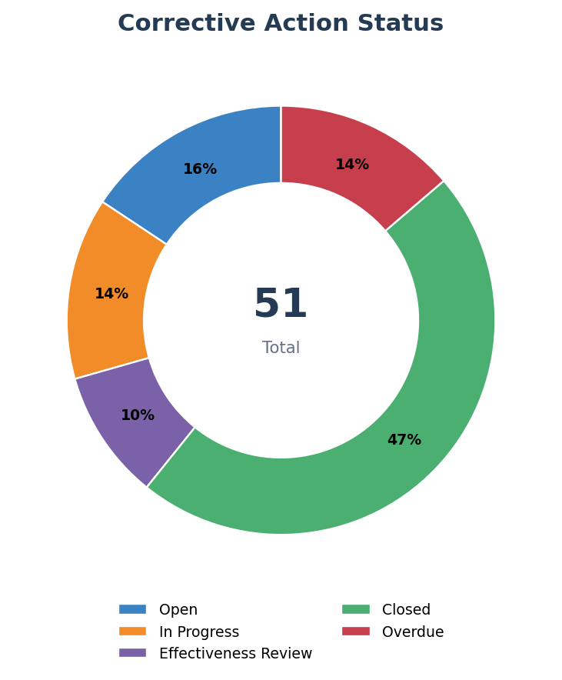

OPEN ACTION AGING | OWNER WORKLOAD
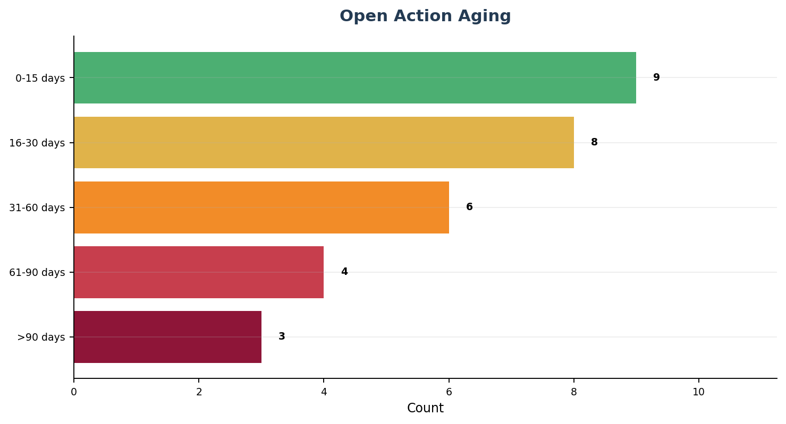 | 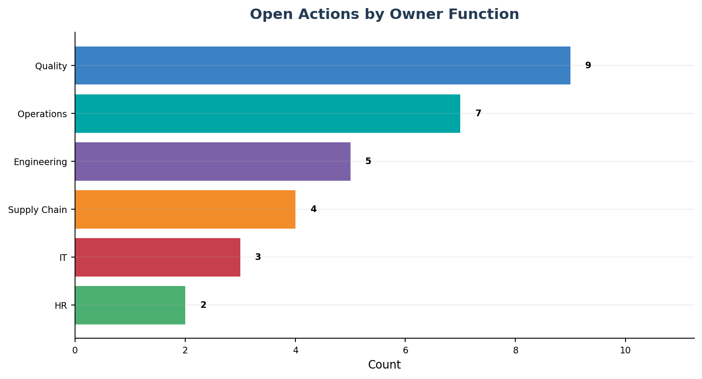

3. CORRECTIVE ACTION REGISTER
CAPA ID | Source | Issue / Nonconformity | Department | Owner | Priority | Open Date | Due Date | Status | Age | Containment
CAPA-2501 | Customer Complaint | Packaging seal failure caused product leakage | Operations | J. Smith | Critical | May 03 | Jun 14 | In Progress | 58 | Quarantine affected lots; 100% seal inspection
CAPA-2502 | Internal Audit | Calibration records incomplete for two devices | Engineering | L. Chen | High | May 08 | Jun 20 | Overdue | 53 | Suspend equipment; complete impact assessment
CAPA-2503 | Supplier Issue | Incoming material dimensions outside specification | Supply Chain | D. Brown | High | May 12 | Jul 05 | In Progress | 49 | Block supplier lot; increase incoming inspection
CAPA-2504 | Process Deviation | Recurring mixing-temperature excursion | Operations | S. Patel | High | May 18 | Jul 12 | In Progress | 43 | Hold affected batch; verify sensor accuracy
CAPA-2505 | Safety Incident | Machine guarding was bypassed during setup | EHS | A. Nguyen | Critical | May 21 | Jun 28 | Overdue | 40 | Stop equipment; restore guard interlock
CAPA-2506 | QMS Review | Document review backlog exceeded target | Quality | E. Davis | Medium | May 25 | Jul 15 | Open | 36 | Prioritize high-risk procedures
CAPA-2507 | Customer Complaint | Incorrect certificate of analysis issued | Quality | M. Garcia | High | Jun 01 | Jul 18 | In Progress | 29 | Issue corrected certificate; notify customer
CAPA-2508 | IT Incident | Training records unavailable after system outage | IT | C. Ramirez | Medium | Jun 04 | Jul 22 | Open | 26 | Restore backup and manual attendance records
CAPA-2509 | External Audit | Effectiveness evidence missing for closed CAPA | Quality | R. Wilson | High | Jun 08 | Jul 10 | Effectiveness Review | 22 | Reopen verification and collect evidence
CAPA-2510 | Process KPI | First-pass yield below target in Line 3 | Operations | M. Lee | Medium | Jun 12 | Jul 31 | Open | 18 | Increase inspection; launch Pareto analysis

DIRECTOR REVIEW CRITERIA
Trigger | Required Management Response
Critical priority or customer / regulatory impact | Immediate executive notification, containment approval and daily tracking.
Overdue high-priority action | Escalate owner, confirm resources and agree a recovery date.
Repeat nonconformity | Reassess root cause, controls, risk and previous effectiveness conclusion.
Action blocked by investment or cross-functional dependency | Resolve funding, authority or resource constraint at governance meeting.

4. ROOT CAUSE ANALYSIS & INVESTIGATION
CAPA ID | Problem Statement | RCA Method | Evidence Reviewed | Validated Root Cause | Contributing Factors | Investigation Owner | Approval
CAPA-2501 | Seal failures increased from 0.2% to 1.4% after line changeover | Fishbone + 5 Whys | Seal-pressure trend, maintenance logs, operator interviews | Changeover standard did not define seal-pressure verification | Worn tooling; inconsistent setup training | Process Engineering | Quality Director
CAPA-2502 | Calibration records unavailable for two devices during audit | 5 Whys | CMMS history, certificates, access logs | Record-upload responsibility was not assigned after calibration | System notification disabled | Engineering Manager | Quality Systems
CAPA-2503 | Supplier material dimensions exceeded specification | Supplier 8D | Inspection results, process capability, supplier audit | Supplier process drift was not detected due to inadequate SPC reaction plan | Tool wear; delayed escalation | Supplier Quality | Supply Chain Director
CAPA-2504 | Mixing temperature excursions recurred on night shift | Fault Tree | Sensor calibration, alarms, batch records, shift interviews | Alarm threshold did not trigger before process limit was exceeded | Training gap; delayed maintenance | Operations Excellence | Plant Director
CAPA-2505 | Machine guard bypassed during setup | Barrier Analysis | CCTV, interviews, risk assessment, work instruction | Setup method required access not supported by approved engineering controls | Schedule pressure; weak supervision | EHS Manager | COO

ROOT CAUSE ANALYTICS
ROOT CAUSE DISTRIBUTION | PRIORITY DISTRIBUTION
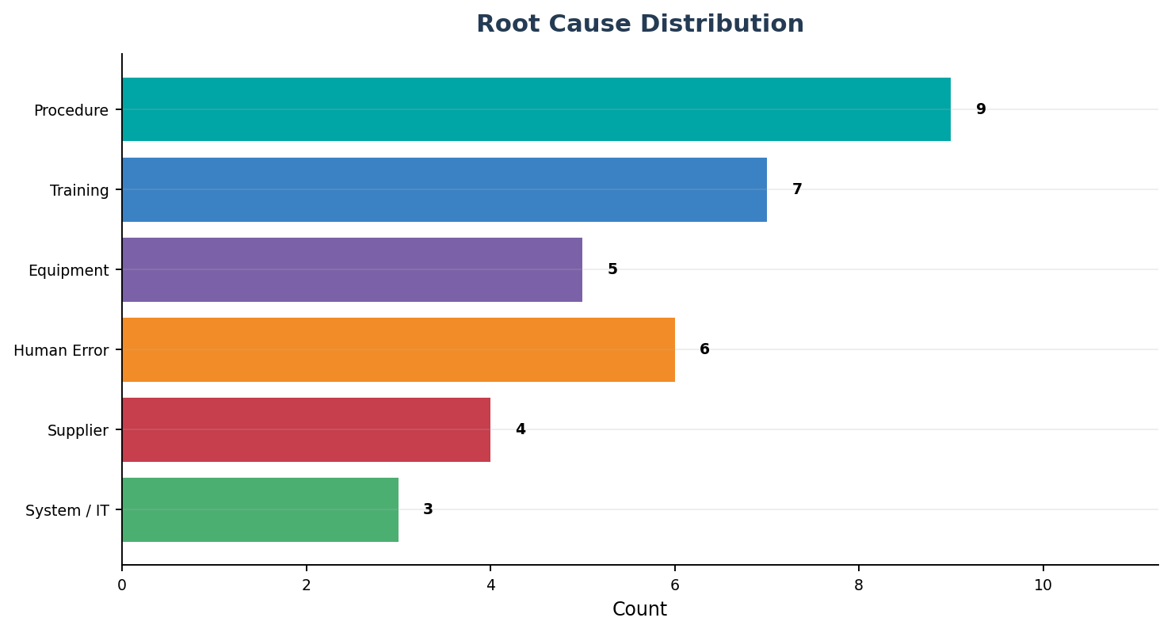 | 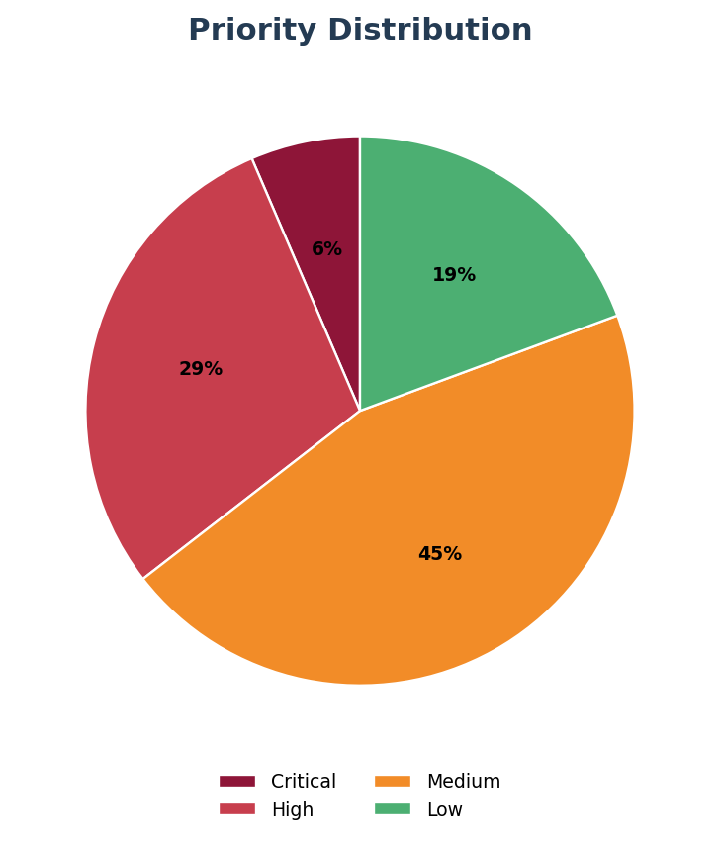

ROOT CAUSE VALIDATION CHECKLIST
Validation Question | Yes / No | Required Evidence
Does the cause explain the complete problem statement? | Yes | Documented causal linkage and supporting data
Can the cause be reproduced or independently verified? | Yes | Test, simulation, audit trail or technical evidence
Would removing the cause prevent or materially reduce recurrence? | Yes | Risk assessment and proposed-control rationale
Have systemic, process, human, equipment and supplier causes been considered? | Yes | Completed RCA method and team review

5. ACTION PLAN & IMPLEMENTATION CONTROL
Task ID | CAPA ID | Corrective / Preventive Action | Owner | Priority | Due Date | Status | Progress | Evidence / Deliverable
ACT-01 | CAPA-2501 | Revise changeover standard to include verified seal-pressure settings | Process Engineering | Critical | Jul 08 | In Progress | 70% | Approved standard and validation results
ACT-02 | CAPA-2501 | Replace worn sealing tooling and define life-cycle control | Maintenance | High | Jul 05 | In Progress | 85% | Installed tooling and PM schedule
ACT-03 | CAPA-2502 | Assign calibration-record upload responsibility and workflow | Engineering | High | Jul 10 | In Progress | 60% | Approved RACI and workflow test
ACT-04 | CAPA-2503 | Require supplier SPC reaction plan and monthly capability submission | Supplier Quality | High | Jul 18 | Open | 35% | Supplier-approved control plan
ACT-05 | CAPA-2504 | Lower alarm warning threshold and implement predictive alert | Automation | High | Jul 15 | In Progress | 55% | System change and verification protocol
ACT-06 | CAPA-2505 | Engineer safe setup access without bypassing guard interlock | Engineering | Critical | Jul 12 | In Progress | 45% | Approved modification and safety validation
ACT-07 | CAPA-2506 | Risk-rank document backlog and reassign reviewers | Document Control | Medium | Jul 20 | Open | 30% | Recovery plan and closure dashboard
ACT-08 | CAPA-2509 | Define effectiveness evidence requirements in CAPA procedure | Quality Systems | High | Jul 10 | Effectiveness Review | 90% | Revised procedure and reviewer training

IMPLEMENTATION CONTROL SUMMARY
Control | Current Position | Director Expectation
Actions on schedule | 6 of 8 | Recover overdue critical actions within five working days.
Evidence complete | 4 of 8 | Evidence must be objective, approved and traceable to the CAPA.
Resource constraints | 2 actions | Resolve engineering and supplier-quality capacity conflicts.
Cross-functional dependencies | 3 actions | Confirm owners and decisions in weekly governance meeting.

ACTION WORKLOAD BY FUNCTION | IMPLEMENTATION AGING

6. EFFECTIVENESS VERIFICATION & RECURRENCE CONTROL
CAPA ID | Verification Method | Success Criteria | Review Date | Reviewer | Result | Evidence | Next Decision
CAPA-2490 | Three-month packaging defect trend | Defect rate <=0.3% and no repeat complaint | Jul 15 | Customer Quality | Effective | Trend report and complaint review | Close and standardize learning
CAPA-2492 | Audit of calibration-record workflow | 100% records uploaded within 3 days | Jul 18 | Internal Audit | Partially Effective | Audit sample: 92% on time | Extend monitoring for 30 days
CAPA-2495 | Supplier capability review | Cpk >=1.33 for three consecutive lots | Jul 22 | Supplier Quality | Pending | Two accepted lots; third pending | Maintain incoming inspection
CAPA-2497 | Night-shift batch review | Zero excursions in 20 consecutive batches | Jul 28 | Operations Quality | Effective | Twenty-two compliant batches | Close after management approval
CAPA-2499 | Safety observation and setup audit | No bypass behavior in 30 observations | Aug 05 | EHS | Ineffective | Two unsafe deviations observed | Reopen RCA and implement engineering control

EFFECTIVENESS VERIFICATION | RECURRENCE TREND
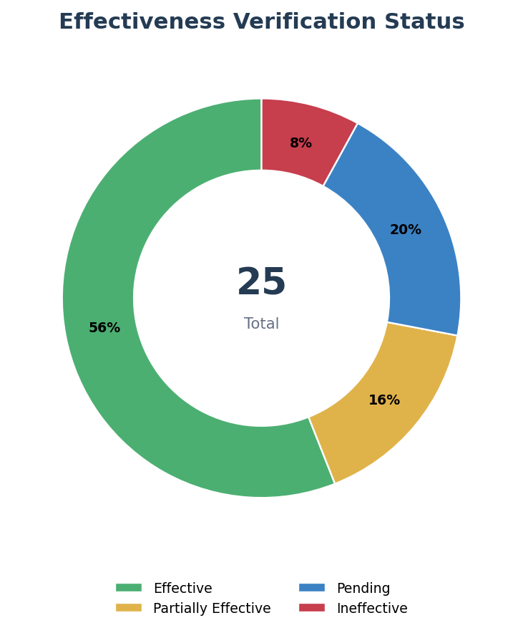 | 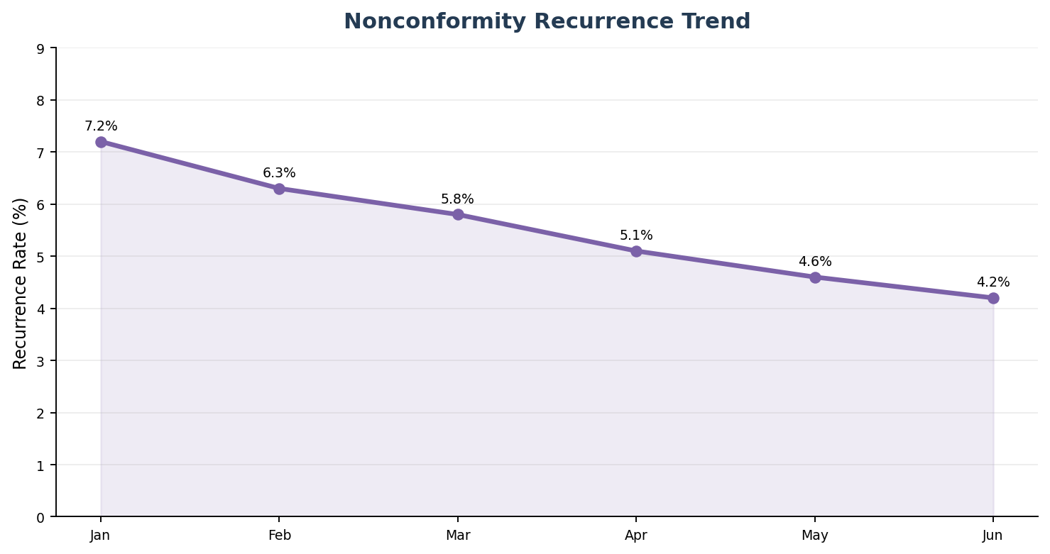

CLOSURE GATE
Closure Requirement | Evidence Required | Approval
Root cause validated | Approved investigation and causal evidence | Investigation Owner + Quality
Actions fully implemented | Completed tasks and approved deliverables | Action Owners
Effectiveness confirmed | Defined success criteria achieved | Independent Reviewer
Residual risk accepted | Updated risk assessment within appetite | Risk Owner / Director
Lessons learned deployed | Updated procedures, training, controls and communication | Process Owner
7. MANAGEMENT REVIEW, ESCALATION & APPROVAL
OVERDUE HIGH / CRITICAL  4  Immediate recovery plans | BLOCKED ACTIONS  2  Engineering and supplier resources | PENDING EFFECTIVENESS  5  Independent review required | REPEAT ISSUES  3  Reopen root cause analysis

Executive Topic | Current Position | Decision / Direction | Accountable Executive | Due Date
Critical packaging CAPA | Containment effective; permanent controls 70% complete | Approve weekend engineering support and supplier tooling review | Operations Director | Jul 08
Safety guard bypass | Overdue critical action; engineering change not complete | Stop affected setup method until validated control is installed | COO | Jul 05
Supplier dimensional failures | Supplier actions progressing; capability not demonstrated | Require executive supplier review and alternate-source plan | Supply Chain Director | Jul 12
Effectiveness backlog | Five reviews pending beyond planned date | Assign independent reviewers and weekly completion target | Quality Director | Jul 10
Document control backlog | Recovery plan exists; resource constraint remains | Temporarily assign two process owners as reviewers | Executive Committee | Jul 15

MANAGEMENT REVIEW SUMMARY
TOP RISKS | OVERDUE / ESCALATED | POSITIVE MOVEMENTS | IMPROVEMENT FOCUS
• Customer-impacting packaging failure  • Unsafe setup method  • Supplier process capability | 4 high/critical overdue  2 blocked actions  5 pending verification reviews | Closure rate improved to 86%  Recurrence reduced to 4.2%  Monthly closures exceed openings | • Faster containment approval  • Stronger root-cause validation  • Evidence-based effectiveness review

APPROVAL & SIGN-OFF
Role | Name | Approval / Decision | Date | Signature
Quality Systems Director | ________________ | Portfolio review completed | ____________ | ________________
Department Director | ________________ | Resources and action ownership confirmed | ____________ | ________________
Risk / Compliance | ________________ | Residual risk and obligations reviewed | ____________ | ________________
Executive Sponsor | ________________ | Critical actions and escalations approved | ____________ | ________________
Management Control Note: Corrective actions must remain open until implementation evidence, effectiveness results and residual-risk acceptance are complete.

